December 15, 2020

Walk A Calming Outdoor Labyrinth at The Armenian Heritage Park in Massachusetts
By Sophia

Boston is filled with fantastic urban green spaces to explore, but this little park is something special.
The Armenian Heritage Park features a gorgeous labyrinth that’s truly one-of-a-kind. Walking this labyrinth is a great way to unwind and admire the beauty of the city.

Here’s what you need to know.
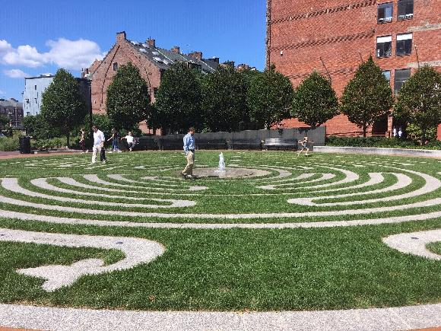Facebook/Armenian Heritage Park on the Greenway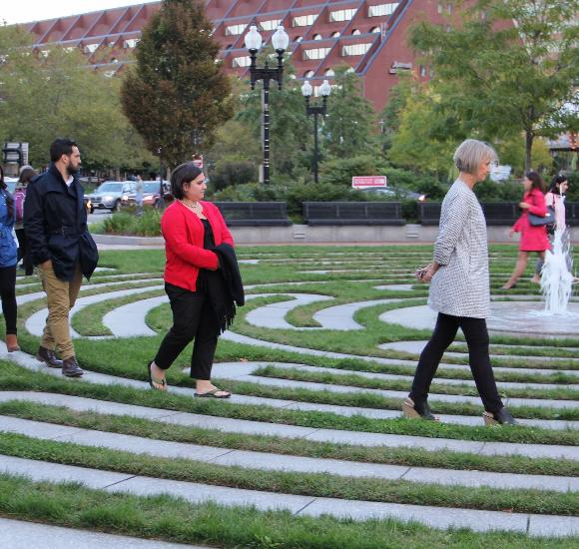Armenian Heritage ParkArmenian Heritage ParkArmenian Heritage ParkFacebook/Armenian Heritage Park on the Greenway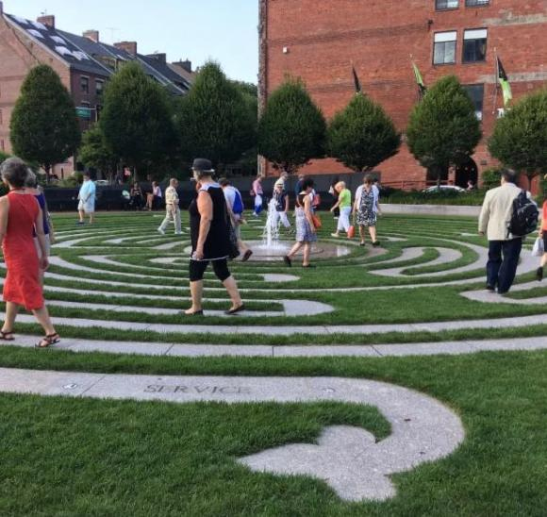Armenian Heritage Park
You can find out more about visiting the Armenian Heritage Park labyrinth by visiting the park’s website.

